Для подключения:

XpsDocument xps_document = new XpsDocument("./test.xps", System.IO.FileAccess.Write);

XpsDocumentWriter xps_writer = XpsDocument.CreateXpsDocumentWriter(xps_document);

Нужно подключить:

using System.Windows.Xps;

using System.Windows.Xps.Packaging;

а чтобы VisualStudio увидел их нужно установить в

SolutionExplorer/References/ AddReferences галочки возле:

* ReachFramework
* System.Printing

https://wpf.2000things.com/2011/03/25/256-use-a-fixeddocument-to-display-content-at-fixed-locations/

#256 – Use a FixedDocument to Display Content at Fixed Locations

MARCH 25, 2011 [2 COMMENTS](https://wpf.2000things.com/2011/03/25/256-use-a-fixeddocument-to-display-content-at-fixed-locations/#comments)

Where **FlowDocument** allows displaying content that flows automatically from page to page, **FixedDocument** allows displaying multiple pages of content in a WYSIWYG (What You See Is What You Get) format.  You add content to the document page by page, and specify exactly where each piece of content should be located.

The **FixedDocument** includes a series of **PageContent** elements, each of which contains a **FixedPage** element.

|  |  |
| --- | --- |
| 1  2  3  4  5  6  7  8  9  10  11  12  13  14  15  16  17  18  19  20  21  22  23  24 | <FixedDocument>      <PageContent>          <!-- 7" x 9" page -->          <FixedPage Width="672" Height="864">              <StackPanel Orientation="Vertical" FixedPage.Left="280" FixedPage.Top="150">                  <Label FontFamily="Arial" FontWeight="Bold" FontSize="18" Content="Jane Eyre" HorizontalAlignment="Center"/>                  <Label FontFamily="Arial" FontStyle="Italic" FontSize="14" Content="Charlotte Brontë" HorizontalAlignment="Center"/>              </StackPanel>          </FixedPage>      </PageContent>      <PageContent>          <FixedPage Width="672" Height="864">              <StackPanel Margin="48">                  <TextBlock FontFamily="Cambria" FontSize="14" Width="576" TextWrapping="Wrap">                      There was no possibility etc.                  </TextBlock>                  <TextBlock FontFamily="Cambria" FontSize="14" Width="576" TextWrapping="Wrap" Margin="0,25,0,0">                      I was glad of it etc.                  </TextBlock>                  <Image Margin="0,25,0,0" Source="Twilight.jpg" />              </StackPanel>          </FixedPage>      </PageContent>  </FixedDocument> |

The document shows up in a default viewer.  Here’s page 1:

[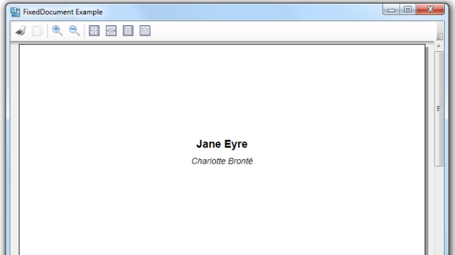](https://2000thingswpf.files.wordpress.com/2011/03/001-page1.png)  
And page 2:

[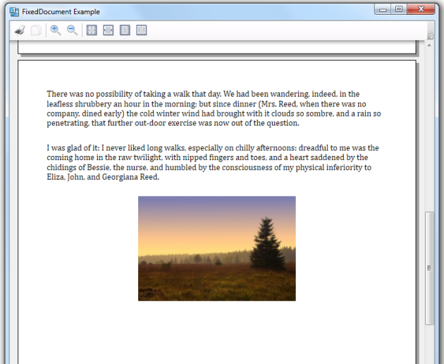](https://2000thingswpf.files.wordpress.com/2011/03/002-page2.png)